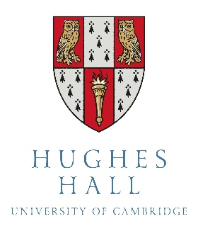

Application for a Hughes Hall PhD Scholarship

Two FULL Hughes Hall PhD Scholarships are awarded each year, in conjunction with the Cambridge Trust, to applicants for full-time PhD study in any subject. These cover both fees and maintenance for all three fee-paying years. Maintenance will be paid by Hughes Hall at the agreed rate, and fees via a Vice-Chancellor’s Award (for a Home/EU student) or a Cambridge International Scholarship (for an Overseas student).

To apply: (a) You must complete your Cambridge University PhD application. In this you must:
- specify Hughes Hall as your first choice college
- apply for funding from the Cambridge Trust (necessary for all co-funding)

(b) You must submit the completed form to scholarships@hughes.cam.ac.uk latest by
31st May 2024.

Applicants will also be considered for several smaller top-up scholarships of £2,500 per year which are kindly provided by benefactors.

YOUR DETAILS
Family name |  | First name(s)
Email

Current course and location
PhD course applied for at Cambridge
Faculty / Department at Cambridge
Contribution to college life, e.g. academic, musical, sporting, social, etc.
… already
(if current or former student)

… proposed
(all applicants)

List other proposed sources of funding, apart from  Hughes Hall and the Cambridge Trust |  |  | Date of application | Date of decision

