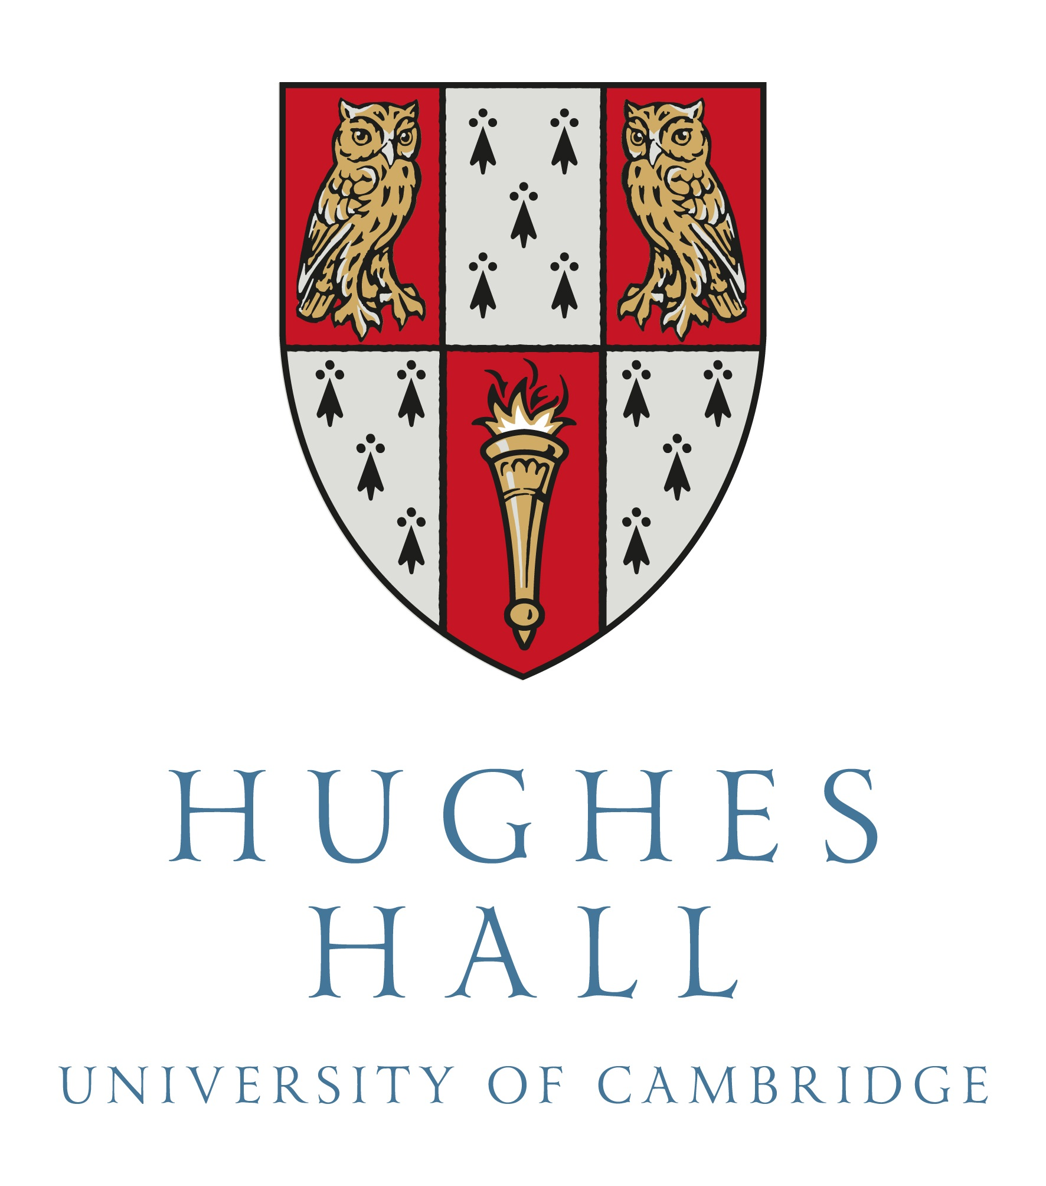

Application for Edwin Leong Travel Grant
Dr Edwin S.H. Leong has provided a very generous benefaction to Hughes Hall to fund student travel. We are extremely grateful for this financial support. As a result, Hughes Hall can offer travel grants to:
- All PhD students, to travel to conferences or other course-related work (max. £250 p.a., though you may combine two years of grant retrospectively)
- Full-time masters students, to travel to conferences or other course-related work (max. £250)
- Medical students, to travel for conferences and/or electives (max. £500 in total)
- BA students, to fulfil compulsory requirements outside Cambridge (max. £250 in total)

Notes
- The College expects you to apply to your faculty / department and other suitable sources, including the Cambridge Philosophical Society for science students. Please indicate these, or give reasons for not applying.
- Applications received after your thesis submission or your course end-date, or for funding after then, will not normally be considered.

Procedure
- First to complete electronically up to ‘8. Student Declaration’. Please get approval from your supervisor and your College Tutor in turn, and then submit to tutorial@hughes.cam.ac.uk.
- The College will normally respond within two weeks, possibly longer in July-August.
- On your return you must submit a short report and copy of all receipts for approval.
- The College will then pay the grant directly into your bank account, normally within two weeks.

1. SUMMARY
Family name |  | First name
Course: PhD, etc |  | Course title
Start term & year |  | College Tutor
Full or part time |  | Supervisor
Faculty / Department
Event Title
Event Location
Event Dates

2. EVENT BENEFIT
& your involvement e.g. paper, poster

3. COLLEGE FUNDING | Previous College support |  | Date | Amount
Travel Grant(s)

Other College Support
4. OTHER FUNDING  (see Note 1 above) | Funding bodies | Date of request | Date of decision | Outcome  in £
Applications to other funds
5. COSTS | Full details | Amount in £
Travel
(in cheapest mode)
Registration
Accommodation
Meals
Visa
Other (give details):

 | Total

6. AMOUNT you are applying for, in light of max. available, other funding and costs

7. a) Will you miss more than two weeks during Full Term?
b) Will you miss a Tier-4-visa contact point?
c) Does your event require a risk assessment?

8. STUDENT DECLARATION | - I declare that the information is true and complete to the best of my knowledge, and agree that the college may check my statements.  - I understand that any false statement or relevant omission may make me liable to refund the grant.  - I declare that I will return any part of the grant not needed for the above purpose, due to lower costs or sufficient funds received from elsewhere.
Signature  (or printed name) |  | Date

9. ACADEMIC REFERENCE | To referee: please complete electronically, then either print, sign and give to student, or email back to student and email copy to tutorial@hughes.cam.ac.uk
Name & role towards student
Benefit of travel to student

Signature  (or printed name) |  | Date
10. COLLEGE TUTOR’S REFERENCE | To applicant: please submit the form (completed so far) to your College Tutor, who will normally want to discuss this with you in person, and certainly so if you wish to combine two years of PhD grant and/or the travel requires a risk assessment.
Comments

Signature |  | Date

