Hughes Hall
Please print all of the details below, fully and legibly and hand in at the Porters’ Lodge. This form will be retained in the Lodge. You will then be issued with a College URN number on a tag for your cycle. Please attach this to the handle bars only. We also recommend you register your cycle with a free to use property registration scheme www.immobilise.com . It is free to register an account and you can add your cycle and ANY valuable items to your free account.
Please ensure that you take and retain a photo of your cycle
FELLOW / STUDENT / STAFF(Delete as necessary) Leaving Date ………/…../……
Full Name: ………………………………................. Date: ………/………/…………
Cycle Make: ……………………………………………. Model: ………………………….
Colour(s): …………………………………… Frame Number: ………………………
Frame number locations
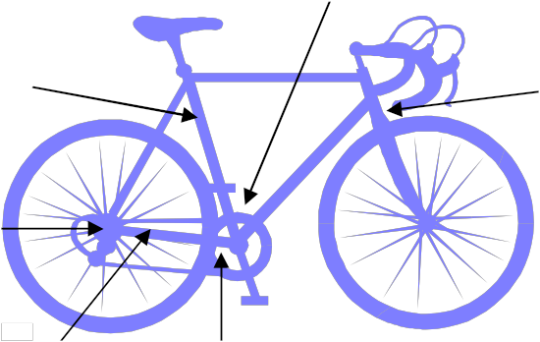

College URN: HH /……………………. (Please fix issued number tag to cycle frame.)
Does this cycle replace a previously registered cycle? Y/N. Details HH/…….….

Please circle type of cycle: Standard Racer Mountain BMX
Folding Hybrid Shopper Electric

Please list all distinguishing features (Basket, rear rack, lever/twist grip gears etc) ……………………………………………………………………………………………………………….
………………………………………………………………………………………………………………………
………………………………………………………………………………………………………………………

